The first step you need to do is open Local Group Policy Editor. Just move to the Start Screen (if you aren’t already there) and type ‘gpedit.msc’. The resulting app will instantly show up under Apps list to the left. Click it to open the Local Group Policy Editor.
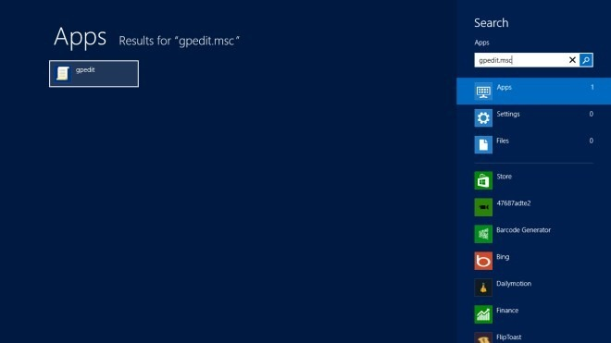
Local Group Policy Editor holds various settings and options and is a place for tweaking with system security, administrative and maintenance policies. For enabling Store, navigate to Computer Configuration > Administrative Templates > Windows Components > Store location.
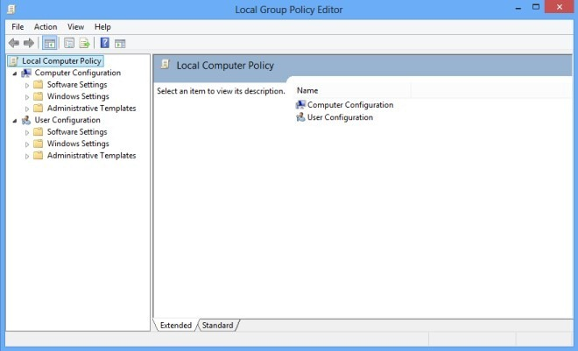

The Store policy folder houses a total of three policies. Right-click Allow Store to Install apps on Windows To Go workspaces and select Edit from the context menu.
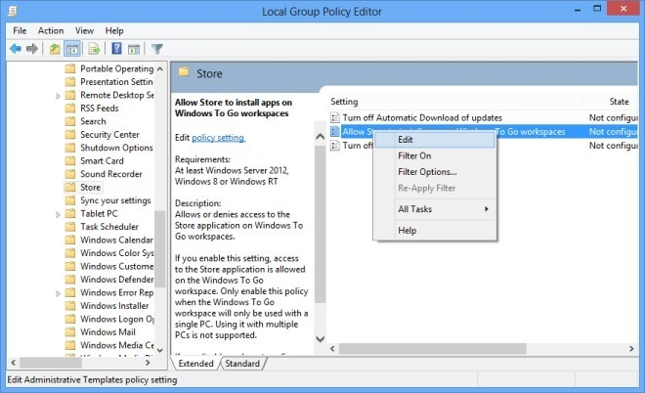
A new window will pop up. To the left of this window, select Enabled option and click Apply to save your changes.
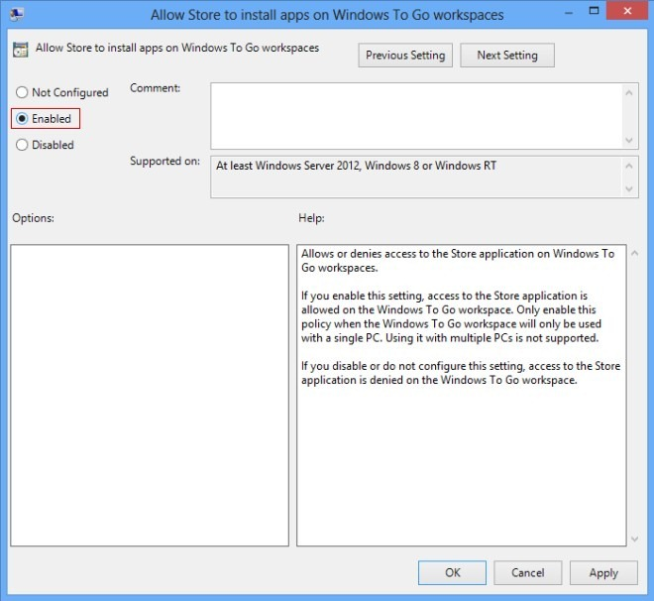
Once you’ve enabled the said option, close the local group policy editor. Now, use the Win+R hotkey combination to bring up Windows Run console. Type in gpupdate /force and hit Enter to apply the changes made to Windows 8 Store policy settings. After updating the policy, you will be able to use Windows Store and install new applications and updates.
