Use a Windows Repair Disc or USB Drive to Fix Your Broken PC [Updated]
By Rich on March 16, 2012 (24 Comments)

- Email
Previously, we showed you how to download Windows 7 and Burn it to a disc/put it on a thumb drive.
Having the whole operating system on disc isn’t necessary if you just need to repair your Windows installation. Recovering or repairing your current installation of Windows is favorable because most recovery software that comes with brand name PCs will wipe your PC back to factory settings.You should have a repair disc on hand to deal with the following situations:
- You’ve made a change to your PC and it now won’t boot into Windows
- You get a message such as NTLDR is missing but your hard drive has not failed
- You get a virus on your PC and need command line access to fix the issue
- Windows starts to boot and then your PC power cycles
In this guide:
- How to make a Windows 7 repair disc yourself
- How to make a Windows 7 repair USB drive
- How to boot from a disc/USB drive and use it to repair your PC
Note: A repair disc cannot be used to install Windows and provides no functionality beyond that of a Windows installation disc. If you already have an installation disc, you can use that for system recovery.

Burn a Windows Vista/7 Repair Disc
To burn your own Windows repair disc you’ll need to be using Windows 7 or Windows Vista SP1 or later release:
1. Click Start, type create and click Create a System Repair Disc (Windows 7) or Create a Recovery Disc (Windows Vista)
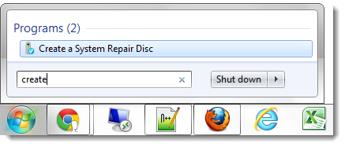
2. Insert a CD/DVD, choose the DVD drive in which the disc resides and click Create Disc
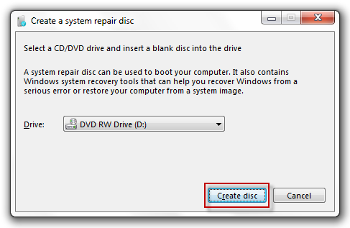
Once the disc is finished, I recommend booting from the disc to test it—before you really need it.

Make a Windows Vista/7 Repair USB drive
If you own a netbook, don’t have an optical (CD/DVD/Bluray) drive etc., you should create a bootable USB repair drive.
To make a bootable Windows repair USB drive you’ll need to:
- Download the Windows recovery disc
- Make your thumb drive bootable
- Copy the recovery files to your thumb drive

1. Download the Windows Recovery Disc
Do a web search for and download one of the following recovery discs
- Windows 7 32-bit Recovery Disc torrent
- Windows 7 64-bit Recovery Disc torrent
- Windows Vista 32-bit Recovery Disc torrent
- Windows Vista 64-bit Recovery Disc torrent
How to use torrents.

2. Make your Thumb Drive Bootable
To prepare your USB thumb drive, you will need to delete all the drive’s files, create a FAT32 active partition, and copy over the Windows recovery files. To do this:
2.1. Press Windows Key+R to open the Run dialog
2.2. Type diskpart and press Enter (If you don’t have diskpart, get it here)
2.3. Type list disk and press Enter
2.4. Type select disk 3 where the “3″ is the corresponding number of your USB drive
2.5. Type clean and press Enter
2.6. Type create partition primary and press Enter
2.7. Type active and press Enter
2.8. Type format fs=fat32 quick and press Enter
2.9. Type assign and press Enter to assign the USB drive a letter in Computer

3. Copy the Recovery Files to Your Thumb Drive.
To copy the files to your thumb drive:
3.1. Open the file you downloaded in step 1 with a utility capable of browsing ISO images (7 zip works well)
  - Download 7zip and install it
  - Right click the ISO file and select 7-Zip > Open Archive
3.2. Extract the contents of the ISO to the USB drive you formatted in step 2

Boot from a Disc/USB Drive and Use it to Repair Your PC
So now you’ve either downloaded a burned the Windows Vista/7 recovery disc, created your own Windows 7 recovery disc, or made a bootable Windows Vista/7 recovery thumb drive.
To boot from your disc/USB:
1. Insert your bootable repair disc/USB drive
2. Reboot your PC
3. When your BIOS is loading (if you have a brand-name PC, this is usually when you can see the brand’s logo), press the key that loads the boot options menu (this is usually displayed as an option on the screen and is typically the ESC/F8 key)
4. Arrow down to “CD-ROM Drive” / “DVD-ROM Drive” / “Removable Media” / “USB Media” and press Enter
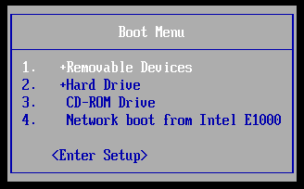
The recovery software will take some time to load:
5. Now select your default keyboard layout:
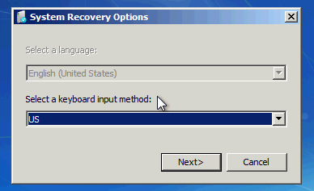
6. After the software detects your installation of Windows, click Next:
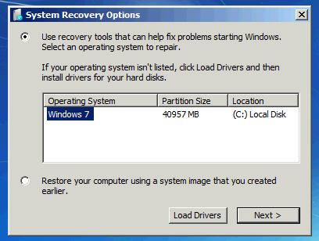

What Can You Do with a Repair Disc?
A repair disc cannot be used to reinstall Windows but can perform many repair tasks. Here is just a small list of what you can do with a repair disc:
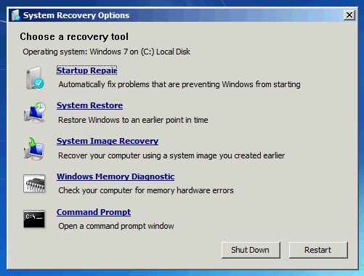
- Startup Repair
- System Restore
- System Image Recovery
- Windows Memory Diagnostic
- Command Prompt
The most commonly used function (for me at least) is the Startup Repair. I use this when I get an error message like “NTLDR Missing”, “Unable to boot” etc. The startup repair checks the MBR, GPT etc for common errors and repairs them.
If you cannot boot into Windows because of corrupted settings, a virus etc, then you may find using a previously-created System Restore point will help you get back to Windows.
If you created a system image using Backup and Restore, you can use it to completely restore your computer to a previous state.
The memory diagnostic is used to check for bad memory sectors (more about the memory diagnostic tool.)
Finally, the command prompt can do (almost) anything the full command prompt can do while using Windows. This can be very useful to run tools like chkdsk to find out why your hard drive is suddenly not working.
For what functions have you used a system repair disc?

